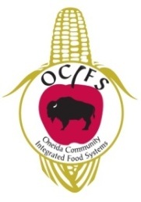
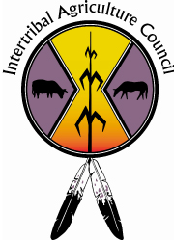
ATTENDEE REGISTRATION FORM
Great Lakes Region Tribal Food Producer Summit
1st Annual Regional Training Conference
April 23-24, 2012 – Oneida, Wisconsin
A block of rooms has been reserved at the Radisson. Call 920-494-7300 or 1-800-333-3333 to
reserve your room. Please mention you’re attending the Great Lakes Tribal Food Summit
Please include payment with completed registration form.
Early Registration Received by April 13 $40.00, after Registration will be $50.00, or a
donation of your local food for the conference of equal value.
All conference registration fees are non-refundable
Full Name:
Title
Organization
Street Address
City/State/Zip Code
Contact Number
Email Address
I am interested in sharing my project information at this conference or future conferences.
Checks preferred & should be made out to Intertribal Ag Council.
CREDIT CARD PAYMENT:
CREDIT CARD TYPE: _______________ (Only Mastercard and Visa are Accepted)
CREDIT CARD NUMBER: ____________________________
AMOUNT: $________________ EXPIRATION DATE: ___________________
NAME ON CARD: _________________________________________________________________
SIGNATURE: _____________________________________________________________________

Please complete this form and mail or fax it to:
Intertribal Agriculture Council
Attn: Daniel Cornelius
1314 Spaight St. #2
Madison, WI 53703
Fax: 406-256-9989
Questions? Call Dan at 608-280-1267 or email dan@indianaglink.com
Check www.iacgreatlakes.com for more information

